CORRESPONDENCE for 7th November meeting.

Bus shelter at Penyard Gardens
Apologies - I should have sent the email below to this email address rather than to Linda's work email.
However, the problem of the state of the Bus Shelter so annoyed me that I sent the mail in haste to first email address I thought of.
Although sent in haste the matter of the state of this bin and bus shelter and my comments below still stand.
I look forward to a response from the Parish Council and a positive solution to this unacceptable situation. Village amenities such as the bus shelters are important for everyone in the village.
Mark Barratt
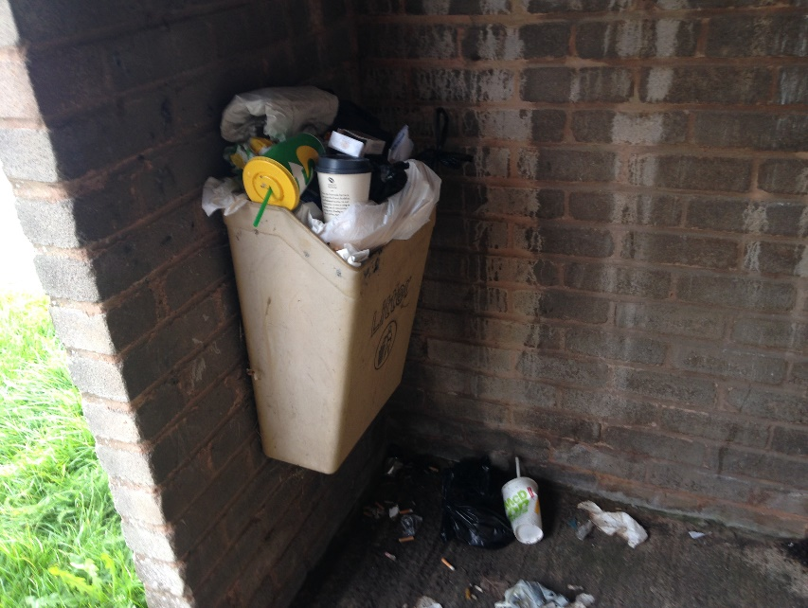

-----------------------------------------------------------------------------------------------------------------------------------
From Mark Hadley re A40 Traffic calming
Further to your email and call for an update, I can advise you of the following.
The S106 monies have yet to be received by the Council, but the developer has now reached the necessary sales milestone and this should be forthcoming shortly.
We are undertaking a topographical survey today (27/11/19) around the Weston Cross Inn junction to ensure our design accommodates any features. Working with our colleagues we have also been able to secure their resources to clear the bank to the south of the A40 of self-seeded saplings to enhance and restore the visibility to this junction/bend. This will involve temporary traffic management to provide safe access and a working zone.
On the other matters you raised:
We will pick up the gateway features in our design. At present we are holding back on this element to allow the TRO process to report initial findings and progress so that we incorporate all designs elements on one stage and do not undertake abortive works.
Further surveys – at this time, as Stuart stated at the meeting, we wish to await progress on the development of the site to the north of the A40. The design would not predicate against the future inclusion of a crossing being installed, but conversely if we were to put something in advance of the scheme, this might then need to be amended depending upon if/how this site was to come forward.
Budget cost estimate- as you state, once our design is finalised we can provide some further detail to you on this.
Additional items:
Whilst this would be ideal, it is difficult to identify where these could be needed. Any works will need to reinstate the road surface but it is an unfortunate nature of highways and utility provision
We will report this to the team, and action as we progress.
Unfortunately I cannot attend your meeting on the 5th, but hope the above provides the information you require at this time,
Kind regards
Mark

